**SKILL: DESIGN PATTERNS AND PRINCIPLES**

**Qn 1: Implementing the Singleton Pattern:**

**Program:**

class Logger{

    private Logger(){

        System.out.println("Singleton instances created!!");

}

    private static class SingletonHelper{

        private static final Logger Instance = new Logger();

    }

    public static Logger getInstace(){

        return SingletonHelper.Instance;

    }

}

public class SingletonPatternExample {

    public static void main(String[] args) {

        System.out.println("Calling first instance!!");

        Logger l1=Logger.getInstace();

        System.out.println("Calling second instance!!");

        Logger l2=Logger.getInstace();

        if(l1 = = l2){

            System.out.println("Same instance is used!!");

        }

        else{

            System.out.println("Different instances are created!!"); }

    }

}

**Output:**

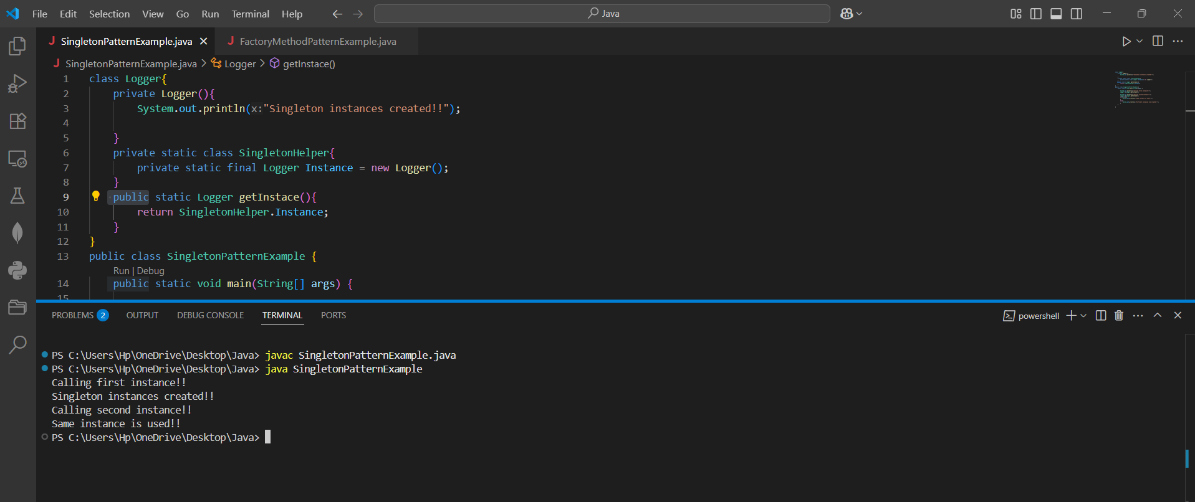

**Qn 2: Implementing the Factory Method Pattern**

**Program:**

interface document{

    String create(); }

class WordDocument implements document{

    public String create(){

        return "WordDocument created"; } }

class PdfDocument implements document{

    public String create(){

        return "PdfDocument created"; }}

class ExcelDocument implements document{

    public String create(){

        return "ExcelDocument created"; } }

abstract class DocumentFactory {

    abstract document createDocument(); }

class WordDocumentFactory extends DocumentFactory{

    public document createDocument(){

        return new WordDocument(); } }

class PdfDocumentFactory extends DocumentFactory{

    public document createDocument(){

        return new PdfDocument(); } }

class ExcelDocumentFactory extends DocumentFactory{

    public document createDocument(){

        return new ExcelDocument(); } }

public class FactoryMethodPatternExample {

    public static void main(String[] args) {

        DocumentFactory factory = new  WordDocumentFactory();

    document doc=factory.createDocument();

    System.out.println(doc.create());

DocumentFactory factory = new  PdfDocumentFactory();

    document doc=factory.createDocument();

    System.out.println(doc.create());

DocumentFactory factory = new  ExcelDocumentFactory();

    document doc=factory.createDocument();

    System.out.println(doc.create()); } }

**Output:**

